5.3.1 Polar Worksheet

- Consider the polar curve .
- Parameterize the polar curve.

We know that .

- At what value of between does the curve reach the point ?

We need to have
From the first equation we see that either (which is impossible) or .
We note that out of these options for the only way that the 2nd equation could result in 1 is if .

- Consider the polar equation.
- Find a formula for . No simplification necessary.

We first parametrize the given curve: .

Now we see that

- Determine the value of between when the curve reaches the point ?

We first need to determine at what value of the curve reaches the point .
We need to have

From the system here we see that only way both equations can be satisfied is if (since and are never equal to 0 at the same time.)
We note that for some integer k. The only angle here that exists in is .

- Determine the slope of the tangent line at the value of found in part (b).

We saw from part (b) that . Therefore, we calculate

- Determine the equation of the tangent line when .

We note that the slope of the tangent line is given by
We also note that at

Therefore we have a tangent line with slope -1 and passing through the point .
This line has the equation
- Find the points on the curve given by from where there are horizontal & vertical tangent lines and singular points.

We note that: . We must first find when .

So we need | So we need
Horizontal tangent lines:
There are horizontal tangents at:

Vertical tangent line
There are vertical tangents at:
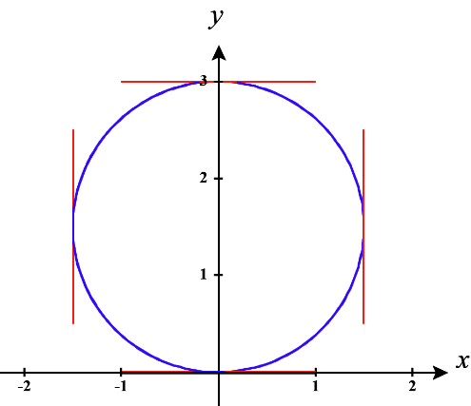

Singular points
There are no singular points.

- Find the points on the curve given by from where there are horizontal & vertical tangent lines and singular points.

We note that: . We must first find when .

So we need | So we need

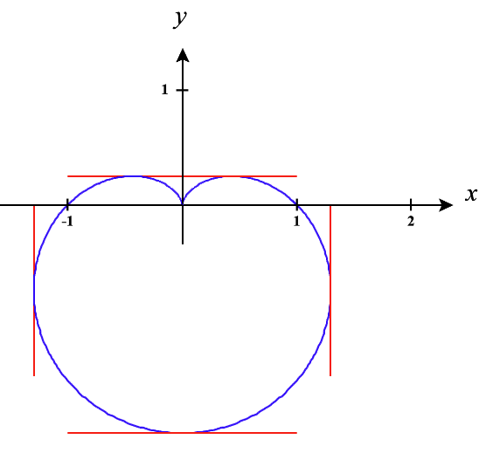
Horizontal tangent lines:
There are horizontal tangents at:

Vertical tangent line
There are vertical tangents at:

Singular points
There is a singular point at:

- Find the points on the curve given by from where there are horizontal & vertical tangent lines and singular points.

We note that: . We must first find when .

So we need  The only value in the given interval is . | So we need  The only value in the given interval is

Horizontal tangent lines:
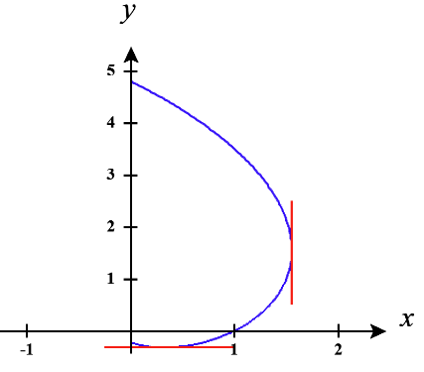
There are horizontal tangents at:

Vertical tangent line
There are vertical tangents at:

Singular points
There are singular points.

- Find the points on the curve given by from where there are horizontal & vertical tangent lines and singular points.

We note that: . We must first find when .

So we need | So we need  Note here that the angle restrictions on allow us to use the inverse sine function.

Horizontal tangent lines:
There are horizontal tangents at:
(Note to solve for r you will need to draw a reference triangle.)

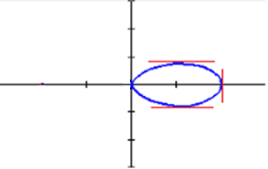
Vertical tangent line
There are vertical tangents at:

Singular points
There is a singular point at:

- Determine the exact length of each of the following polar curves.

- , .

We note that the curve is only traced once since no value of r is ever repeated over the given interval and and are continuous on .

Therefore,

- ,

We note that the curve is only traced once over the given interval since no value of r can ever be repeated on the given interval and and are continuous on .

Therefore,

- ,

We note that the curve is only traced once since no value of r can ever be repeated on the given interval and and are continuous on .

Therefore,
Let and . The bounds become .
So,

- A single trancing of

We first note that this curve is traced out as varies from 0 to .
Also and are continuous on .

Therefore,
Then note that by the identify
.
Note that for , and for , .
Therefore,

- A single tracing of . Do not evaluate this integral.

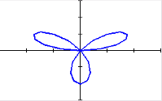
We first note that this curve is traced out as varies from 0 to .
Also and are continuous on .
Therefore, .

